REPORT for Experiment 17
Experiment Title：Purification for target DNA

Instructor(s)：Pinmei Wang

Lab Location：海工楼

Date Performed：2024.12.28

- Introduction
There are many commercial test cartridges or lab scales that offer a variety of systems for the purification of DNA fragments. We introduce two common methods:PCR purification and coagulation purification.
In this experiment,we purify DNA fragments from PCR amplification reaction mixtures in Exp. 15.
The PCR Cleanup cartridge explores a special binder solution that is combined with a commercial centering column to achieve high selectivity and recovery of DNA fragments. The agreement will remove unbound primers (<50nt), enzymes, and unlabeled and luminous dye labeled mononucleotides. DNA recovered through the PCR Cleanup protocol includes these basic steps: binding, washing, and eluting from the silica column.
The agreement will recycle all DNA fragments in the response system. Therefore, the target DNA fragment in the antimix should be unique in size and have no other non-specific DNA fragments. You can preliminarily estimate non-idiotic DNA fragments by calolidine-coagulated electrophoresis. If your target DNA fragment exists at the same time as other DNA fragments, you can use the coagulation purification protocol to purify the target fragment.
Gel purification allow you to separate and purify DNA fragments based on size: The process begins with standard glycocoagulation electrophoresis, which separates in the form of insul base pairs based on the degree of DNA. Once the coagulation is complete, the DNA fragments are visualized at UV and the fragments are selected for comparison with the molecular weight standard.
With Thunderstroke, you can excise DNA bands and purify DNA samples from glycogels under UV irradiation. Recovery of DNA from glycolipogen includes the following basic steps: separation, melting, washing, and washing from the silica column. Once the gel is separated and melted with the DNA bands, the solubilized gel is added to the spin column and the solution is decentralized, which causes all the DNA and other particles to adhere to the filter.
In PCR purification and coagulation purification protocols, DNA is thought to bind to a silica filter through a salt bridge in high presence. After binding, the DNA is washed out and dissociated under low salt conditions, thus disrupting this interaction.
2. Experimental Purpose
（1）Understand the purpose of purification for DNA fragment
（2）Understand the main steps and the mechanisms of purification kit
（3）Be able to choose the suitable way to purify target DNA fragment
3. Equipment and Materials
PCR Cleanup kit (AP-PCR-250, Axygen) (See Appendix H)
Agarose gel DNA extraction kit (Code No.9762, Takara)(See Appendix H)
PCR product of 16S rDNA (From Exp.15)
DNA-dye (see Appendix G)
DNA loading buffer (see Appendix G)
DNA electrophoresis system and gel imaging analysis system
DNA ladder DL5000 (Takara)(see Appendix G)
Agarose(琼脂糖)
Microwave oven
1.5 mL tube
Pipettes and tips
Water bath(水浴锅)
Centrifuge(离心机)
Toothpicks
A clean, sharp scalpel
UV illumination
4. Experimental Procedure
PCR Clean up kit:
1). Add a volume of buffer PCR-A that is 3 x PCR reaction volume to the mixture,If the PCR mixture are in several tubes, combine them and add buffert PCR-A.
2).Set a Spin Column into a collection tube, transfer the mixture (≤ 700 μL once in one Spin Column) from Step l into the Spin Column, and centrifuge at 10,000 rpm for minutes.
3). To improve the recovery rate of DNA, transfer the flow-through to Spin Column again and centrifuge again. If necessary, repeat this step 2-3 times
4). If the mixture are in several tubes, combine the solution of these tubes into one Spin Column by repeating step 2-3.
5). Add 700 μL of buffer W2 into the Spin Column. Centrifuge at 10,000 rpm for 1 min Discard the flow-through.
6)Repeat step 5-add 700 μL of buffer W2 into Spin Column, and centrifuge at10,000 rpm for 1 min. Discard the flow-through.
7),Centrifuge empty Spin Column with Collection Tube at 10,000 rpm for 2 mins to remove residual liquid.
8)Place the Spin Column into a new 1.5 ml tube. Add 30 μL of pre-heated ddH₂O to the center of the Spin Column membrane. Let it stand at room temperature for at least 5 min.
9).Centrifuge at 10,000 rpm for 2 min to elute the DNA.Take 2-5 μL purified DNA to run gel to check if you obtain the target DNA. Keep the purified DNA at -20 or.80 'C until further use.

4.2. Gel Purification kit
1) According to the number of samples, prepare suitable volume of 0.8% agarose gel with TAE(including DNA-dye) in a 200 mL flask boil it in the microwave oven until the liquid is completely transparent without any lumps, cool, and pour it into an agarose gel mould with a wide well comb. After gel solidification (about 20 - 30 min), transfer gel into gel tank.
2) Run gel for 20 - 30 min at ~200V. Remove gel from gel tank, image and save photo.
3) Excise a single target DNA band out of the agarose gel with a clean, sharp scalpel under UV illumination. Briefly place the excised gel slice on absorbent toweling to remove residual buffer.Cut as close to the DNA as possible to minimize the gel volume and increase the recovery rate of DNA. When handling ethidium bromide (EB) stained gels and working in front of UV light,gloves and protective eyewear should be used.
4) Place the excised gel in a clean centrifuge tube (pre-weigh and label the weight of the tube),cut gel into pieces by a toothpick for melting in the butter quickly, and weigh the gel pieces andcalculate the volume of gel. l mg of gel is equivalent to a 1 μL volume.Note: If the size of gel is too large, the gel can be cut into several tubes.Follow the steps (5 - 14) as shown in Fig.17.1. to purify your target DNA.
5) Add a volume of buffer GM that is 3 × the gel weight to the gel pieces. After being placed in buffer, the gel pieces are incubated at around 37 ℃ to melt the agarose. During incubation procedure, every 2 - 3 mins gently invert the tube until gel completely is melted. The color of the solubilized gel solution should be yellow. If the color is orange or purple, add 10 - 30 μL 3M sodium acetate (pH 5.2) until the solution return to yellow.
6) Set a Spin Column into a collection tube, transfer the solubilized gel solution (≤700 μL oncein one Spin Column) from Step 5 into the Spin Column, and centrifuge at 10,000 rpm for 1minutes.
7) To improve the recovery rate of DNA, transfer the flow-through to Spin Column again and centrifuge again. If necessary, repeat this step 2 - 3 times
8) If the target DNA gel pieces are in several tubes, combine the solution of these tubes into one Spin Column by repeating step 7 - 8.
9) Add 700 μL of buffer WB into the Spin Column. Centrifuge at 10,000 rpm for 1 min.Discard the flow-through.
10) Repeat step 9 — add 700 μL of buffer WB into Spin Column, and centrifuge at 10,000 rpm for 1 min. Discard the flow-through.
11) Centrifuge empty Spin Column with Collection Tube at 10,000 rpm for 2 mins to remove residual liquid.
12) Place the Spin Column into a new 1.5 mL tube. Add 30 μL of pre-heated ddH2O (or Elution Buffer) to the center of the Spin Column membrane. Let it stand at room temperature for at least 5 min.
13) Centrifuge at 10,000 rpm for 2 min to elute the DNA.
14) Take 2 - 5 μL extracted DNA to run gel to check if you obtain the target DNA. Keep the
purified DNA at -20 or -80 ℃ until further use.

5. Record and Results
Label the bands in your gel picture, print and stick the picture here:
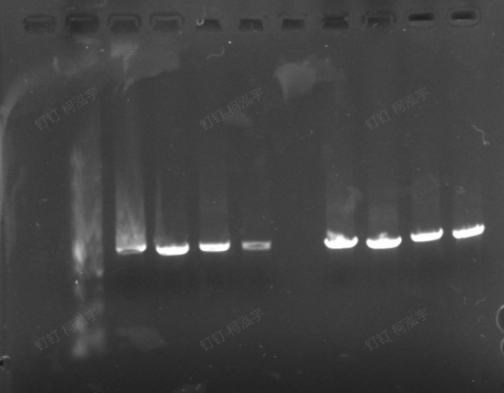
M 1

Lane M:DNA Marker
Lane 1:Our sample

Which protocol do you choose to purify the 16S rDNA fragment? Why? Explain it

6. Discussion
List the down applications after purification for the target DNA.

Transformation and Cloning
Inserting DNA into plasmids or other vectors for cloning purposes.
Transforming bacteria or other host cells with the cloned DNA.
Polymerase Chain Reaction (PCR)
Amplifying specific regions of the DNA for further analysis or manipulation.
Sequencing
Determining the precise order of nucleotides in the DNA sequence.
Restriction Digests
Cutting DNA at specific recognition sites to generate fragments for mapping or analysis.
Southern Blotting
Detecting specific DNA sequences within a sample after electrophoresis and transfer to a membrane.
Quantitative PCR (qPCR)
Quantifying the amount of DNA present in a sample.

